# Software Requirements Specification

# PRJ566 – Fall 2024

# PRJ566 – Team No:

# Name of Project:

# Project Leader:

**Last updated:**

**Team Members:**

**1.**

**2.**

**3.**

**4.**

**5.**

# TABLE OF CONTENTS

**Part 1**

1. **Introduction/Overview - Document Information**
   1. **Document Authors**
   2. **Document Conventions**
   3. **Document Purpose**
   4. **Intended Audience**
   5. **Group Agreement**
2. **Project Overview**
   1. **Project Proposal**
   2. **Stakeholders and Users**
   3. **Functional Requirements**
   4. **Nonfunctional Requirements**
   5. **Project Scope**
   6. **System risks**
   7. **Operating Environment**
   8. **UI/UXD Interface Mockups**

**Part 2 will follow later**

# 1 - Introduction/Overview - Document Information

## 1.1 Document Authors

The team members’ names

## 1.2 Document Purpose

## 1.3 Intended Audience

## 1.4 Group Agreement

**TEAM AGREEMENT**

**Team #:**

**Project Title:**

**Project Time Frame:**

**Team Members:**

**Team Leadership:**

**Team Functions:**

* *We will share information through MS Teams, OneDrive, WhatsApp, e-mail and meetings.*

**Team Meetings:**

**Team Problems:**

**Team Commitment**

**The undersigned members agree to work together on the project until the end of the PRJ666 next Semester. They recognize that as a team and individually they are responsible for the quality of all deliverables.**

**Name Date**

|  |  |
| --- | --- |
|  |  |
|  |  |
|  |  |
|  |  |

ShapeShapeShapeShapeShapeShapeShapeShape

# 2 - Project Overview

## 2.1 Project Proposal

Project Background

A brief overview of the background to the project and why it is being carried out.

**Problem Statement**

|  |  |
| --- | --- |
| The Problem of: | Describe the problem |
| Affects: | The stakeholders affected by the problem |
| The impact of which is: | What is the impact of the problem |
| A successful solution would: | Key benefits of your successful solution |

**Product Vision**

|  |  |
| --- | --- |
| For | Describe the target customer(s) |
| Who | Give statement of the need or opportunity |
| The Product Name | Is a [product category] |
| That | Provide statement of key benefit; that is the compelling reason to buy |
| Unlike | Primary competitive alternative |
| Our product | Statement of primary differentiation |

## 2.2 Stakeholders and Users

|  |  |
| --- | --- |
| Stakeholder Name/Identifier | Category |
| CEO (Chief Executive Officer) | Administration, Sponsor |
| Construction Manager and Scheduler | Administration, User  Needs accurate up to date information for costing and scheduling of project details |
| Administrative Assistant | User |
| Schedulers | User |
| Cost Accountant | User |
| Project Leader | Developers |
| Developers | Developers |

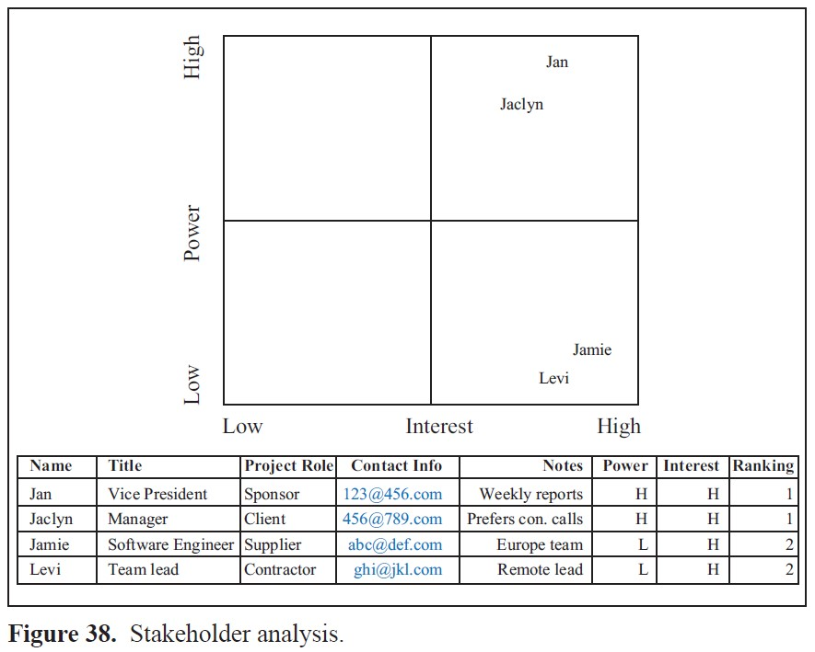

## 2.3 Functional Requirements

## 

## 2.4 Nonfunctional Requirements

Operational, Performance & Security Requirements

## 2.5 Project Scope

## 2.6 System Risks

|  |  |
| --- | --- |
| **Risk** | **Response** |
| The use of Voice Recognition adds complexity, introducing more ways to hack into your device | Implement various security measures and keep code modular in order to reduce complexity and increase security |
| Some of the team members are not familiar with Android Studio (IDE used to develop Android apps) | Hold team sessions to go over the IDE and how to initialize an APK for app testing /  or the whole team will meet twice a week to complete video tutorials related to . . . |
|  |  |
|  |  |
|  |  |
|  |  |

## 2.7 Operating Environment

**Hardware Environment:**

Examples

Adequate server capacity for hosting the application.

Reliable POS (Point of Sale) systems integrated with the software.

Efficient networking infrastructure to support real-time data processing.

**Software Environment:**

Examples

Stable operating systems on all devices (e.g., Windows, iOS, Android).

Compatibility with widely used database management systems.

Integration capabilities with existing restaurant management software.

**Security Environment:**

Examples

Robust cybersecurity measures to protect against data breaches.

Regular updates and patches for security vulnerabilities.

**Compliance Environment:**

Examples

Adherence to regulatory standards relevant to the food and beverage industry.

Compliance with data protection laws for customer privacy.

## 2.8 UI/UXD Interface Mock-ups